Name: - Sanket Pansara

Sap I’d: - 500095871



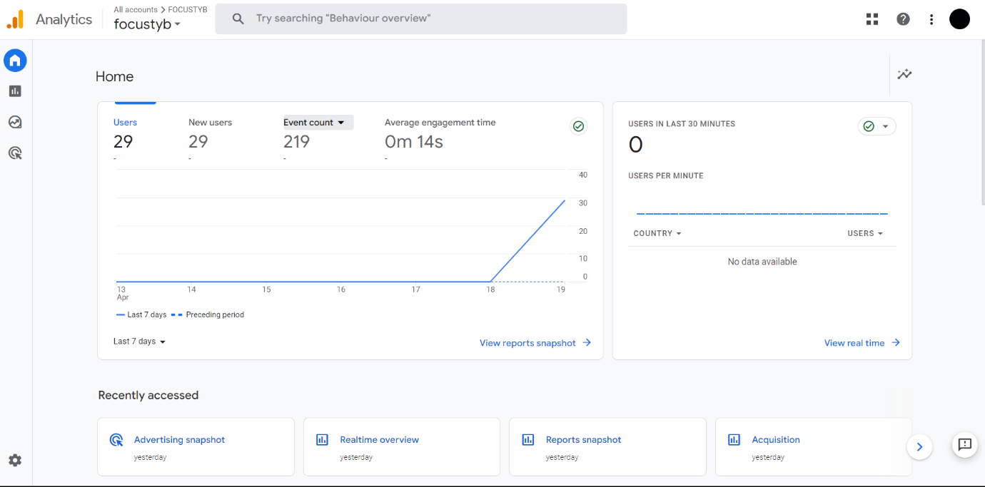

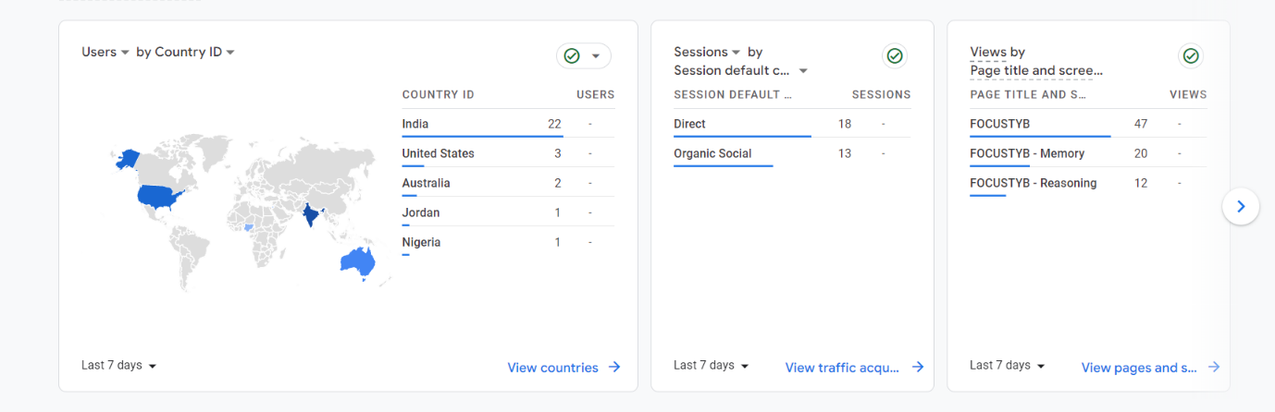

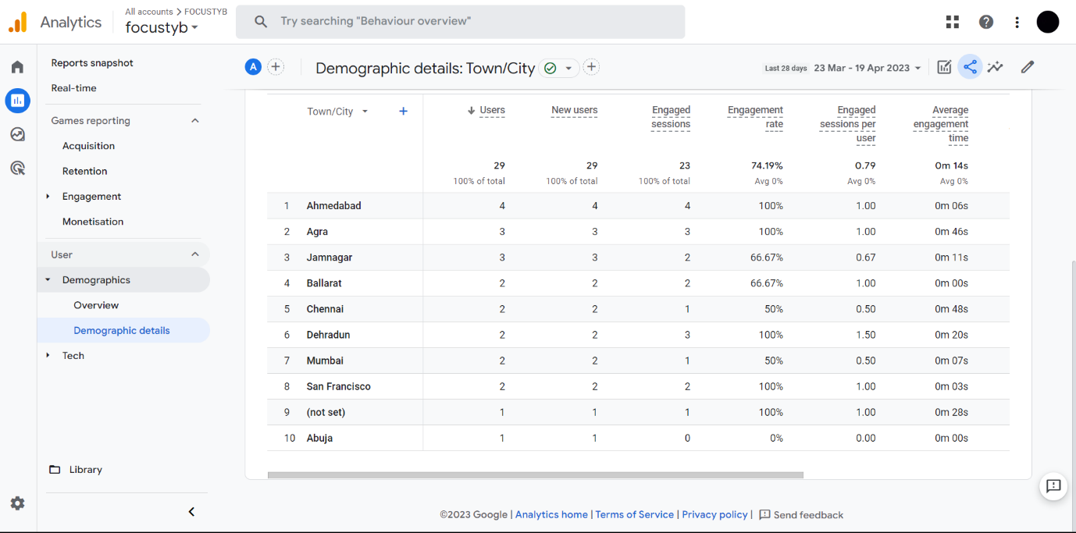

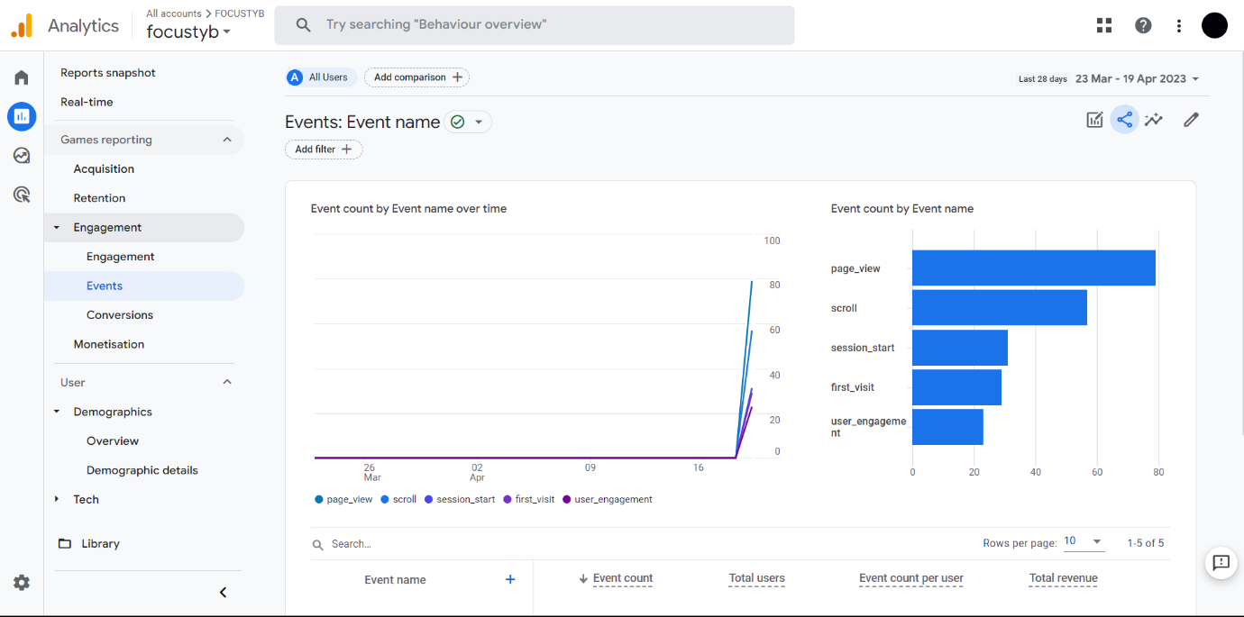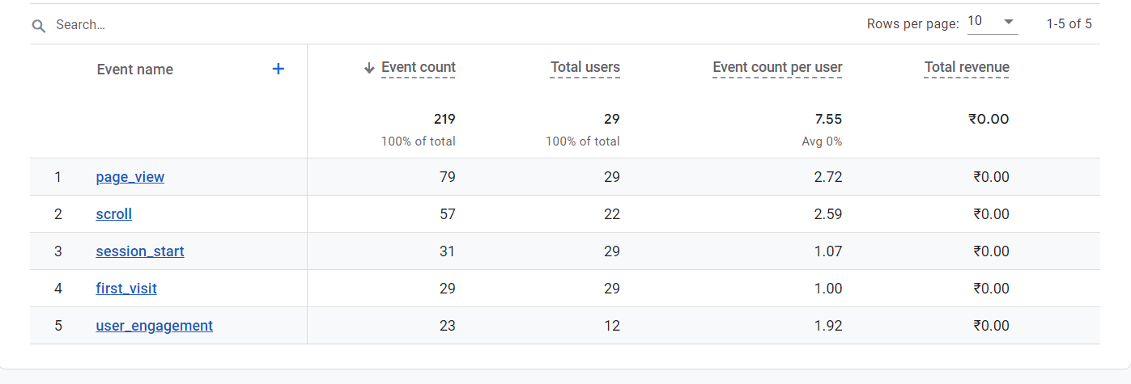

* Here are some of the different types of reports by Google Analytics:-

1. **Audience Reports:** This report provides insights into the demographic and geographic characteristics of your website visitors, including their age, gender, location, and interests.
2. **Acquisition Reports:** This report helps you understand where your website traffic is coming from, including search engines, social media, email campaigns, and other referral sources.
3. **Behaviour Reports:** This report shows how users interact with your website, including which pages they visit, how long they stay, and what actions they take.
4. **Conversion Reports:** This report tracks user actions that result in a conversion, such as completing a purchase or filling out a contact form.
5. **E-commerce Reports:** This report provides insights into your online store’s performance, including sales data, product performance, and customer behavior.
6. **Real-Time Reports:** This report provides up-to-date information about your website’s activity, including how many users are currently on your site, which pages they are visiting, and what actions they are taking.
7. **Custom Reports:** This report allows you to create customized reports that are tailored to your specific needs and goals.